Assignment #4 – Business 100
Name:

Background information needed to answer Question #1:

Review the organizational chart below and the different types of company hierarchies:

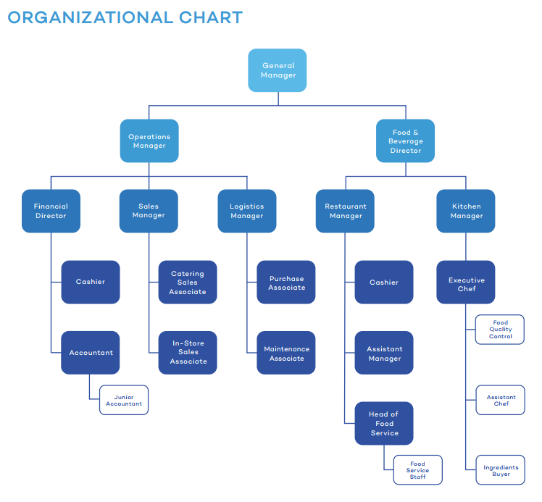

Key Learning: Organizational Structures: Tall versus Flat Hierarchies
A tall hierarchy is a traditional way to organize management. There are many levels of employment, and a few employees at each level report up to a manager at the next level. For example, at Starbucks, baristas report to store managers, and store managers report to regional managers, and regional managers report to executives at headquarters. This works really well for Starbucks! Baristas are carefully and consistently trained and supervised so that you can count on the same cup of coffee at any store. Employees who want to advance can work hard and make their way up the chain to gain more management responsibilities. Business is efficient and quality is consistent.

On the other hand, some businesses prefer a flat hierarchy. When Paul and Ari founded Zingerman’s Delicatessen, they wanted to make sure that every employee felt empowered to make decisions to improve the customer experience. In their service-oriented business, Paul and Ari’s employees get their jobs done in creative and collaborative ways. A flat hierarchy makes this possible.

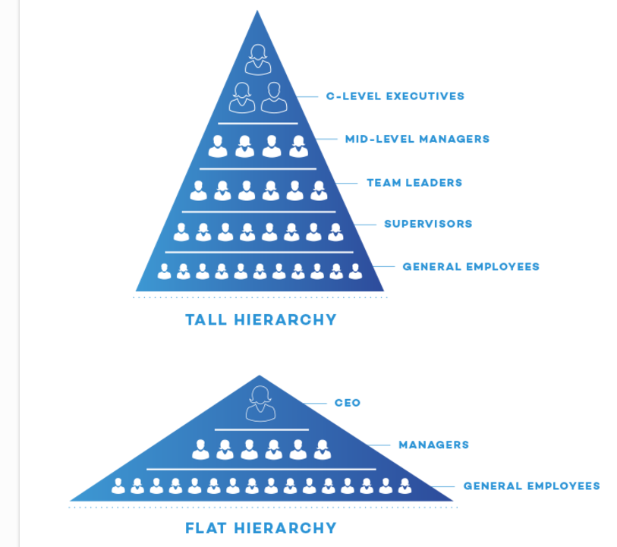

Question 1: Organizational Structure

Based on your knowledge of hierarchies, would you say that this company has a tall hierarchy or a flat hierarchy and why?

- Tall Structure
- Flat Structure

Background information needed to answer Question #2:

Review how this company applies the Human Resources Cycle by reviewing the following memo:

“Hello, Head of HR here providing you a bit more insight into our process. I’ve included a flow chart on the high-level process (see below) but also wanted to provide a more detailed explanation. Our HR cycle begins with our recruiting department. We have campus recruiters who attend career fairs and develop relationships from select universities around the country. We also do a substantial amount of recruiting through LinkedIn, targeting professionals further along in their career with the backgrounds we look for. We then conduct phone screens with qualified candidates, followed by rigorous in-person interviews. We hire approximately 10% of the candidates we interview in-person. Once an employee comes on-board, our performance management system begins. Employees are required to write out goals and objectives after their first 30 days on the job. They have regular ongoing conversations with their direct managers, as well as with assigned mentors, regarding their performance. On or near their anniversary date, we conduct a formal performance review. In the review, we evaluate how the employee performed relative to the goals they mapped out for themselves, and relative to our expectations. Based on the result of the performance review, we make compensation adjustments and promotion decisions. Finally, when an employee does exit their role, by transitioning to another role within the company or by terminating their employment, we conduct formal exit interviews. Hope this helps. Look forward to your feedback on how we can improve.”

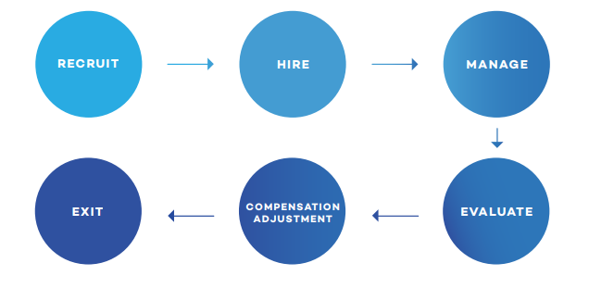

KEY Learning: these are all of the components of the Human Resources Cycle:

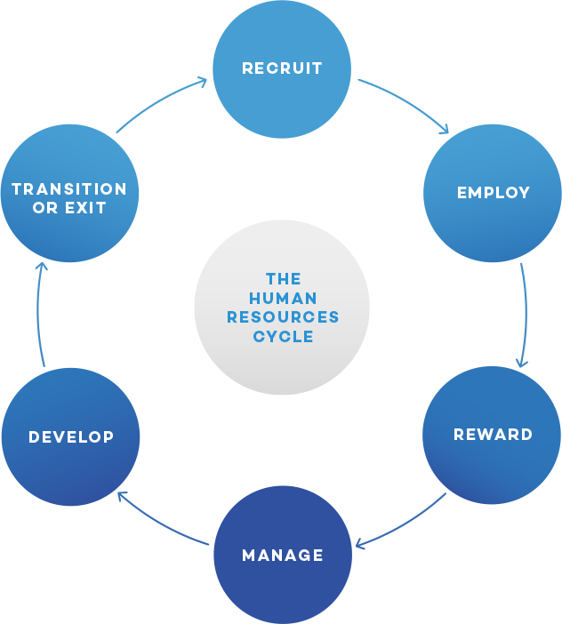

Question #2: Human Resources

What Step of the Human Resources Cycle is missing from what is described in the memo?
- Recruit
- Employ
- Reward
- Manage
- Develop
- Transition or Exit

Why is the missing step so important?

Background information needed to answer Question #3:

You have been asked to help improve the leadership style of the team leader in order to meet the team’s performance goals. The team leader has given you a description of what is most comfortable in terms of leading others in this memo:

“Hi, I’m writing this email in response to your request for an overview of my leadership style. First, I think it’s important to tell you how I got to my role as the General Manager. I started at the bottom and I’ve worked my way up through the ranks by being the top performer in every role I’ve had. I’ve worked hard to get to where I am today, nothing has been given to me, and I believe everyone reporting to me should have a similar mindset and work ethic. I’m looking for people who can keep up with my level of performance; that’s what we need to achieve our organizational goals. I demand a lot from people. Some might say I’m difficult to please, but I believe in continually pushing people to achieve results they previously didn’t think possible. To do that, my employees must move fast and execute on the directives I give them. If they can’t, then I need to find others who can keep up. That may sound harsh, but I view maintaining a strong performance-based culture as my responsibility as a leader. Please feel free to contact me with any questions.”

KEY Learning Here are the different leadership styles
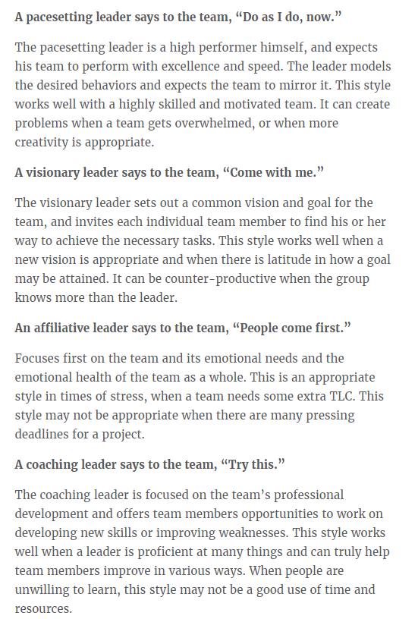
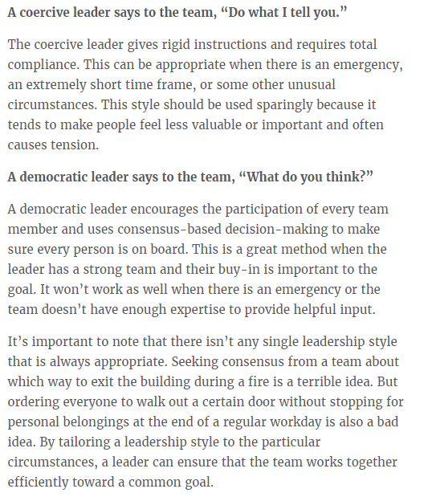

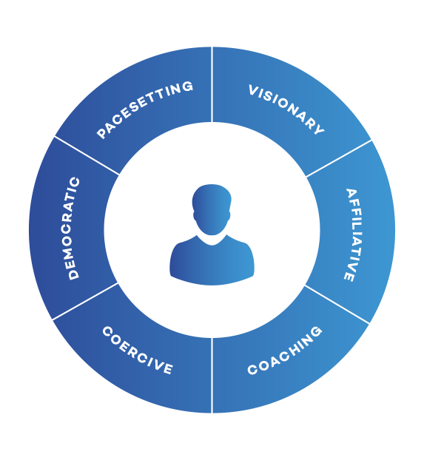
Question #3: leadership style

Identify this leader’s leadership style:
- Pacesetting
- Visionary
- Affiliative
- Coaching
- Coercive
- Democratic

Explain why you selected that style. Also, provide 2 benefits and 2 drawbacks to that leadership style.

Next step: submit your work
- Save this document to your desktop
  - Navigation: select file at the top, save as – select desktop, and select save
- Log into your class and select Assignment #4 on the left, scroll down and select “submit your work”, click browser my computer, find your file on the desktop, click open, then click submit.
- If you have any issues email me or call me.
I will provide you assignment feedback and you can then make any changes you would like and resubmit for grading.
Congrats on completing assignment #4!

